**Abstract**

A short abstract (summary) of your contribution may be inserted here. Use short, direct sentences. It should be as concise as possible. It should be complete, self-explanatory and should not require reference to the paper itself. The abstract should be informative, giving the scope and emphasizing the main conclusions, results, or significance of the work described.

Keywords: first, second, last

JEL codes: A100, A110

# Introduction

This document provides a template and guidelines for authors using MS Word or similar word-processor to prepare a conference proceedings paper. Please follow the instructions carefully.

With a new document based on this template open in MS Word, prepare your paper as appropriate, using the set of styles with prefix SIER (e.g. SIER Heading 1) available from the template (see below for further instructions on use of styles). Delete the text of these instructions from your final document before submission. Name your file with the name and surname of the first author (e.g. alois_novak.docx).

# Typographical Style and Layout

This document has been set up with a set of styles with prefix SIER that should give the correct layout automatically. For example, the heading above is in the style ‘SIER Heading 1’. Please always use these styles. They include the spacing required between different items automatically; it should not be necessary to add blank lines. Instructions have been added here in case the styles fail or for users unfamiliar with them.

Styles are included in this template for all necessary elements of a paper e.g.: Title, Author, Author address, Abstract, Headings, Figure captions, Table titles, Equations, References, etc.

Main Text Font and Paragraphs

The whole text must be written using predefined styles. It is possible to use at most 3 levels of headings (main chapter, Introduction, Methodology and Data, Results, Discussion and Conclusions, Acknowledgements, References + 2 sublevels). Styles for three levels of headings are provided – ‘Heading 1’, ‘Heading 2’ and ‘Heading 3’. For the first paragraph after the Heading use style First paragraph. Do not separate paragraphs with blank lines.

## Title, Author and Abstract

### Title

Title should be concise, precise, factual, has to describe the main topic in the most precise way. It cannot include abbreviations, except the most general ones, e.g. DNA.

### Author name and address

State the names of all co-authors, without titles (e.g. Jan Smith). Below the author names please state full addresses of all co-authors in English (including e-mail). Please note that instead of faculty or department address the official address of the seat of the university is required. E.g.: Alois Smith, Department of Applied Biology, Faculty of Biology, University of Graz, MasterStreet 1, 20997 City, Country, e-mail: smith@unigraz.aut.

# Abstract

Factual outline of the topic, used methods, summary of results and overall conclusions and recommendations (10–15 lines of texts). Abstract cannot contain anything which is not a part of the actual text.

### Keywords

A set of keywords should be comprehensive, but concise, typically 7–10 words or phrases. Initial letters of keywords are written in lower-case.

Equations, Figures and Tables

### Equations

Please use Equation tool (*Insert* ⟶ *Equation*) to create displayed mathematical equations. Below is an example:

(1)



### Figures

Illustrations should be included directly in the file you submit and also inserted separately as individual attachments. They should be at high resolution (300 dpi). All illustrations must be numbered consecutively using Arabic numbers in bold type (e.g. Figure 1, etc.). The size of a figure should be commensurate with the amount and value of the information the figure has to convey. All illustrations should be in monochrome (greyscale). Centre figures on the width of the page. Position figures at the top and the bottom of a page. Do not assemble figures at the back of your paper, but place them as close as possible to where they are mentioned in the main text. Pictures are also inserted separately as individual attachments. Figure should be formatted using Figure style. Use ‘Figure caption’ style for the figure caption.

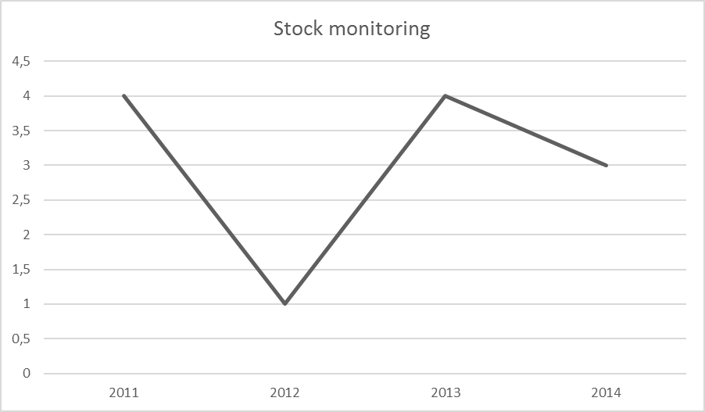

Figure 1: Figure caption

### Tables

Tables should be numbered consecutively (in Arabic numbers) and centered on the page width. Table headings (style ‘Table caption’) should be placed above tables. Use horizontal lines do emphasize Table head and the end of table. Avoid vertical lines where possible. Detailed explanations or entries should be typed directly beneath the table. Position tables at the top or bottom of a page and place them as close as possible to where they are mentioned in the main text.

Table 1: Table caption

|  |  |  |  |  |
| --- | --- | --- | --- | --- |
|  | Model 1 | Model 2 | Model 3 | Model 4 |
| Constant | −0.1333 | −0.1058 | −0.1084 | −0.1146 |
| Discount rate | −0.3069 | −0.2981 | −0.3103 | −0.3039 |
| Dummy variable | −0.1041 | −0.1053 | −0.1070 | −0.1019 |

# Methodology and Data

In the interest of reproducibility, please provide a concise description of research material and used scientific methods. If these are not original methods, give reference to the paper where this method was originally published.

# Results

Results section should contain evaluation and exact description of achieved results. If the nature of a paper allows it, state the statistical significance of the results as well.

# Discussion and Conclusions

In discussion, please provide a confrontation of the achieved results with previously published papers, author’s opinion of established differences, his/her attitude to the results. The discussion section also provides a space to outline the need of further potential solution or importance for the development of science, society or practice.

References

Provide in-text citations using the following style Name Author (year of publication). In the final list of references, format citations using the Harvard style e.g. (Comfort, 1997). Arrange the citations in alphabetical order, based on the first author’s name, without numbering. The reference list must contain citations of all used sources and cannot contain citations of sources which were not actually used.

COMFORT, A. 1997. A good age. 2nd Edition. London: Mitchell Beazley.

HOLLIDAY, A., HYDE, M. and KULLMAN, J. 2004. Intercultural communication: an advanced resource book. London: Routledge. [Online]. Available at: http://www.dawsonera.com/. [Accessed: 15 August 2011].

JONES, P. and EVANS, J. 2006. Urban regeneration, governance and the state: exploring notions of distance and proximity. Urban Studies 43(9): 1491–1509. Academic Search Complete [Online]. Available at: http://web.ebscohost.com. [Accessed 2010, August 17].

ROEDER, K., HOWDESHELL, J., FULTON, F., et. al. 1967. Nerve cells and insect behavior. Cambridge, MA: Harvard University Press.

SATTLER, M.A. 2007. Education for a more sustainable architecture. In: Sun, wind and architecture: proceedings of the 24th International Conference on Passive and Low Energy Architecture. National University of Singapore, 22–24 November. Singapore: Department of Architecture, National University of Singapore, 844–851.

WIT, J. S., PONEMAN, D. B. and GALLUCI, R. L. 2004. Going critical : the first North Korean nuclear crisis. Washington, D.C.: Brookings Institution Press.